Title: Nexa AI Assistant Chatbot
Done by : Pritesh Ram Keshri Project Number : 01, Submission Date: 29th May 2025
Overview:

This project creates a user-friendly web interface for interacting with Ollama language models using Streamlit. The application works as an AI Assistant Chatbot which allows users to configure model parameters, customize the AI personality, and engage in conversational interactions through an intuitive chat interface. The system maintains conversation history and provides real-time streaming responses.
Moreover, it would work in offline mode also.

Key features include:
- Model selection and parameter configuration
- Customizable AI personality through system prompts
- Real-time streaming responses with typing indicators
- Session-based chat history management
- Responsive UI with custom styling

Libraries used:

streamlit - For building the web application interface and UI.

ollama - Python client for interacting with Ollama models.

time - For adding response streaming delays.

Dataset Details:

No Dataset is used in this project. Only we have used pretrained model llama3.2.
Llama 3.2 utilizes 3billion parameters. These models are designed for various use cases, from lightweight text-only applications on mobile devices to more sophisticated vision and reasoning tasks.

APIs Integrated:

Ollama Local API (http://localhost:11434)

Source code 1: App Configuration and Styling
File Name : Importing libraries, app.py

import streamlit as st
from ollama import Client
import time

# Initialize Ollama client
client = Client(host='http://localhost:11434')

# App configuration with custom theme
st.set_page_config(
page_title="Nexa AI Assistant",
page_icon="🤖",
layout="wide",
initial_sidebar_state="expanded"
)
# Custom CSS styling
st.markdown("""<style>...custom CSS rules...</style>""",
unsafe_allow_html=True)

Source code 2: Sidebar Configuration

# Sidebar for settings
with st.sidebar:
st.title("⚙️ Nexa Settings")
st.markdown("---")

# Model selection
st.subheader("Model Configuration")
available_models = ["llama3.2"]
selected_model = st.selectbox("Select Model", available_models)

# Configuration sliders
temperature = st.slider("Creativity", 0.0, 1.0, 0.7)
max_length = st.slider("Response Length", 100, 2000, 500)

# Personality settings
st.subheader("Personality Settings")
system_prompt = st.text_area("Customize Nexa's personality",
"You are Nexa, a helpful AI assistant...", height=150)

# Connection status
st.subheader("System Status")
try:
client.generate(model=selected_model, prompt="test")
st.success("✅ Ollama is connected and ready")
except:
st.error("⚠️ Ollama connection failed")

Source code 3: Main Chat Interface, app.py

# Main chat area
st.title("💬 Nexa AI Assistant")
st.caption("Your intelligent assistant for all queries")

# Initialize chat history
if "messages" not in st.session_state:
st.session_state.messages = []
st.session_state.messages.append({
"role": "assistant",
"content": "Hello! I'm Nexa..."})
# Display chat history
for message in st.session_state.messages:
with st.chat_message(message["role"]):
st.markdown(message["content"])
Source Code 4: Response Generation

# Generate response function
|def generate_response(prompt):
try:
response = client.generate(
model=selected_model,
prompt=prompt,
system system_prompt,
options={'temperature': temperature,
'num_predict': max_length})
return response['response']
except Exception as e:
return f"⚠️ Error: {str(e)}"

# Chat input processing
if prompt := st.chat_input("Type your message..."):
# Add user message to chat history
st.session_state.messages.append({"role": "user", "content": prompt})

# Display user message
with st.chat_message("user"):
st.markdown(prompt)

# Generate and display assistant response
with st.chat_message("assistant"):
message_placeholder = st.empty()
full_response = ""

# Get response
assistant_response = generate_response(prompt)

# Stream response with typing effect
for chunk in assistant_response.split():
full_response += chunk + " "

time.sleep(0.05)
message_placeholder.markdown(full_response + "▌")
message_placeholder.markdown(full_response)

# Add assistant response to history
st.session_state.messages.append({
"role": "assistant",
"content": full_response
})

Source Code 4: Initialization Commands

Step-by-step Python Code to Run Ollama 3.2 from Terminal:

import subprocess

# Function to run a terminal command and print the output
def run_command(command):
print(f"Running: {command}")
result = subprocess.run(command, shell=True, text=True, capture_output=True)
print(result.stdout)
if result.stderr:
print("Error:", result.stderr)

# 1. Install Ollama (Linux/macOS) — skip if already installed
# You can comment this out if Ollama is already installed
run_command("curl -fsSL https://ollama.com/install.sh | sh")

# 2. Start the Ollama service (only necessary if it isn't running)
run_command("ollama serve &")

# 3. Pull the llama3 model (or any other model you want to use)
run_command("ollama pull llama3")

# 4. Run a prompt with the model
response = subprocess.run(
['ollama', 'run', 'llama3', '-p', 'What is the capital of France?'],
text=True,
capture_output=True
)
print("Model response:", response.stdout)
Output screenshots:

Here , are the snapshots of my working project.

1.This is the starting interface of my project.
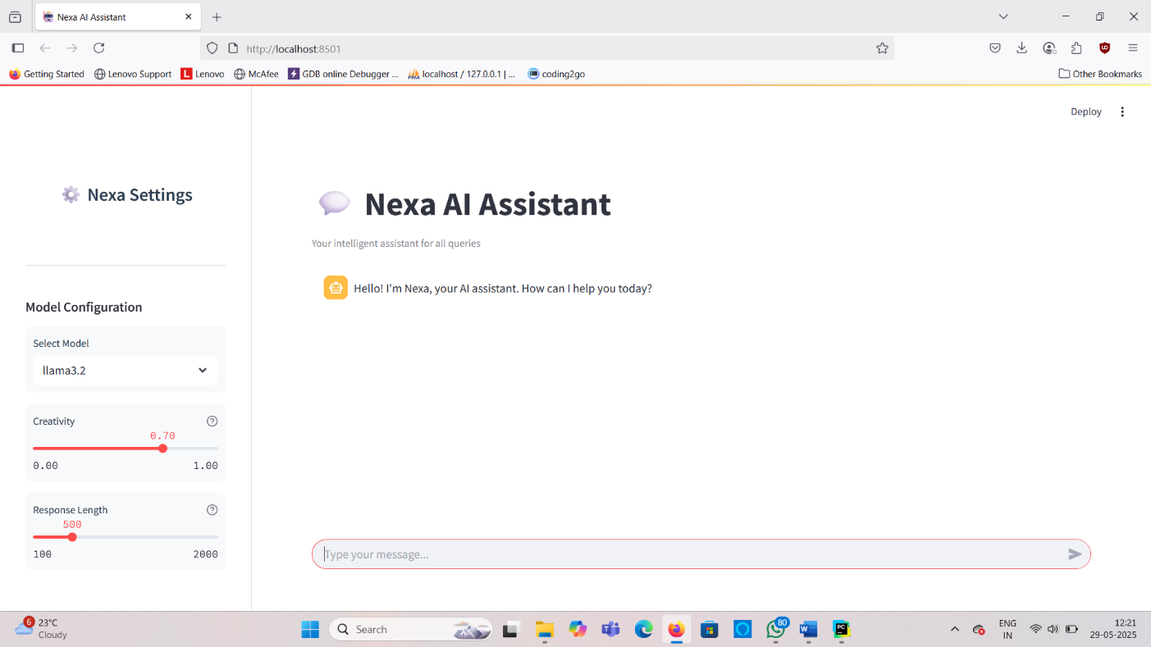

2.Sidebar Configuration : This would be a combination of the model configuration and personality settings.
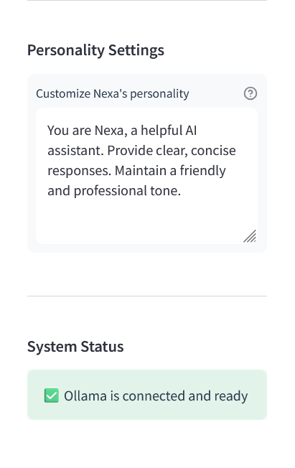
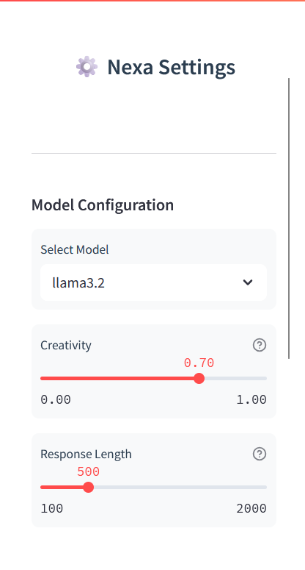

3.Main Chat Interface : The primary chat interface shows a natural conversation flow and the input area.

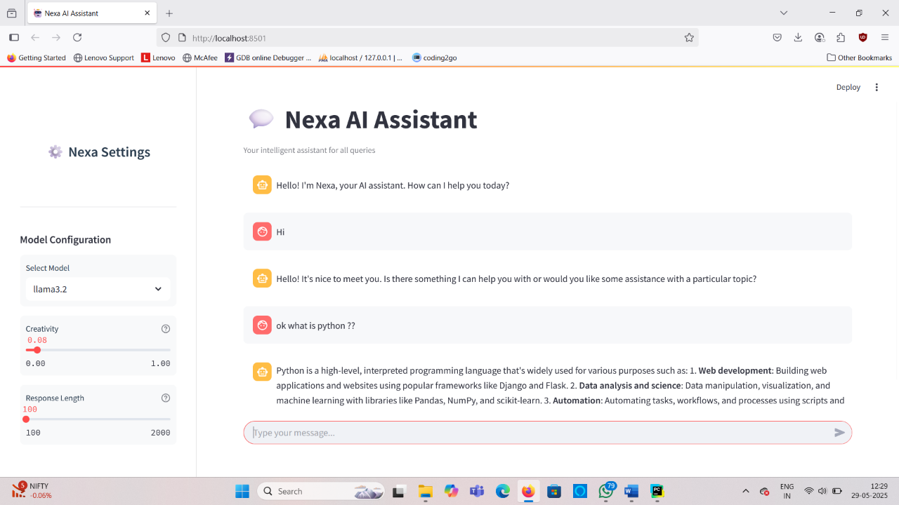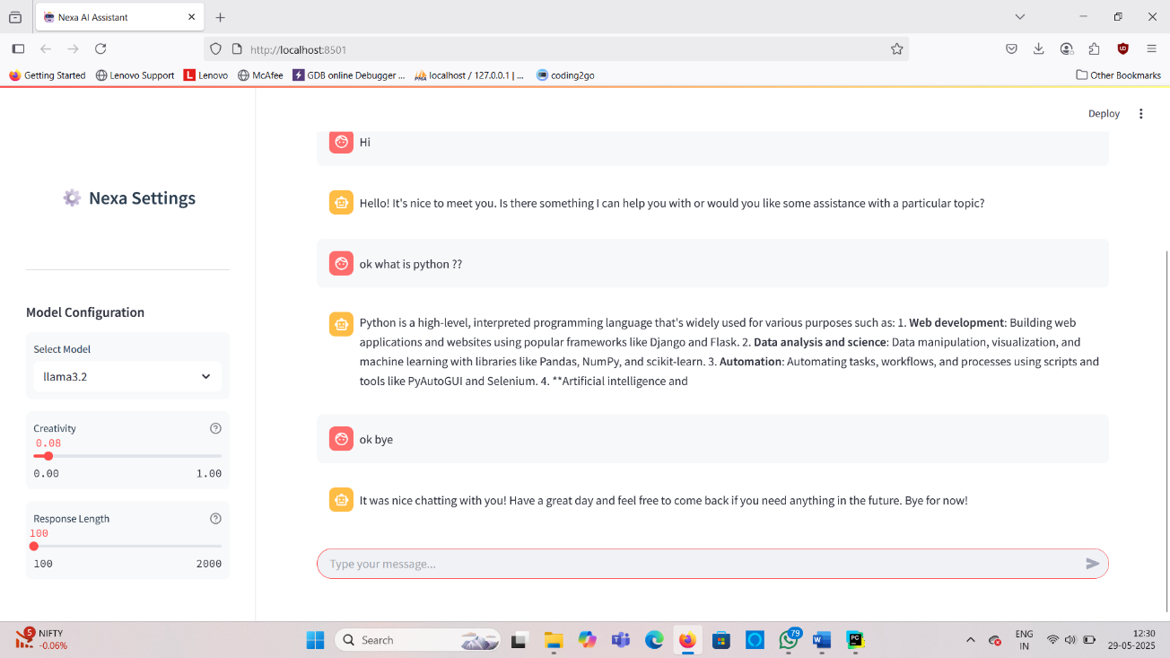

What you learned:

Through this project, I gained hands-on experience with:

- Streamlit Framework: Learned to build interactive web apps using Streamlit components.

- Ollama Integration: Connected to local LLMs through Ollama API.
- Session Management: Implemented chat history persistence using Streamlit's session state.
- UI Customization: Created responsive layouts with custom CSS styling.
- Real-time Streaming: Implemented typing indicators and progressive response display.

What the Skills you gained:

- Building conversational AI interfaces with Streamlit.
- Integrating local language models into web applications.
- Creating dynamic UIs with interactive widgets.
- Managing application state and session persistence.
- Implementing responsive designs with custom CSS.
- Handling API communication and error management.

Real Time Applications:

- Personal AI Assistant: Local, private alternative to cloud-based chatbots.
- Education Tool: Interactive learning companion for students.
- Development Prototyping: Rapid interface creation for testing.
- Attendance Systems: Authenticate signatures in paper-based attendance or approval sheets.
- Research Interface: Configurable platform for experimenting with LLM parameters.

Further Enhancement Suggestions:

- Multi-model Support : Add support for additional Ollama models (Llama 3, Mistral, etc.)
- Conversation Memory : Implement long-term conversation memory using vector databases.
- File Uploads : Add document analysis capabilities through file uploads.
- Deployment Options : Containerize app for easy deployment (Docker).
- Advanced Features : Add image generation, code execution, or web search capabilities.

